

**User Interface Design Guidelines**

**Submitted By**

**Alina Raza**

FA17-BCS-072-B

**Submitted To**

**Mr. Awais**

Human Computer Interaction



**COMSATS University Islamabad**,**** Sahiwal Campus

October 1, 2020

YouTube

# Visibility of System Status

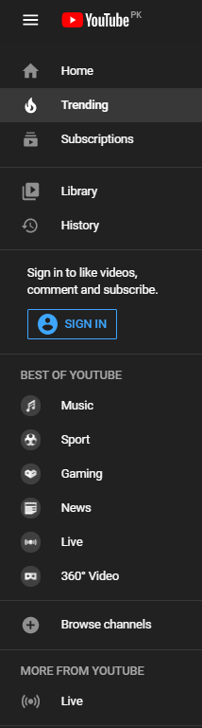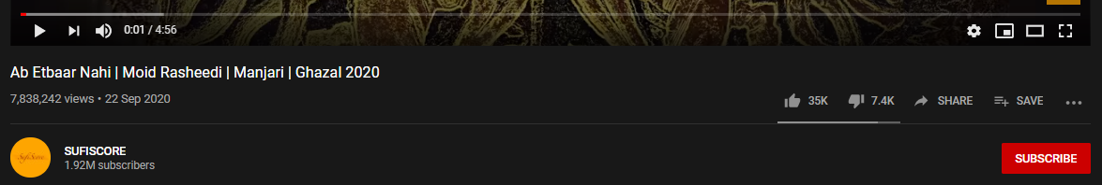

* Subscribers
* Timeline
* No. of Likes
* No. of Dislikes

# Match between system and Real World

* Icons (Home, Trending, Music, Sports e.tc.)

# User control and Freedom

* Play/Pause
* Stop
* Subscribe/Unsubscribe

# Consistency and Standards

* Standard Play/Pause Controls
* Play/Pause with icon
* Play/Pause with Icon Button

# Error Prevention

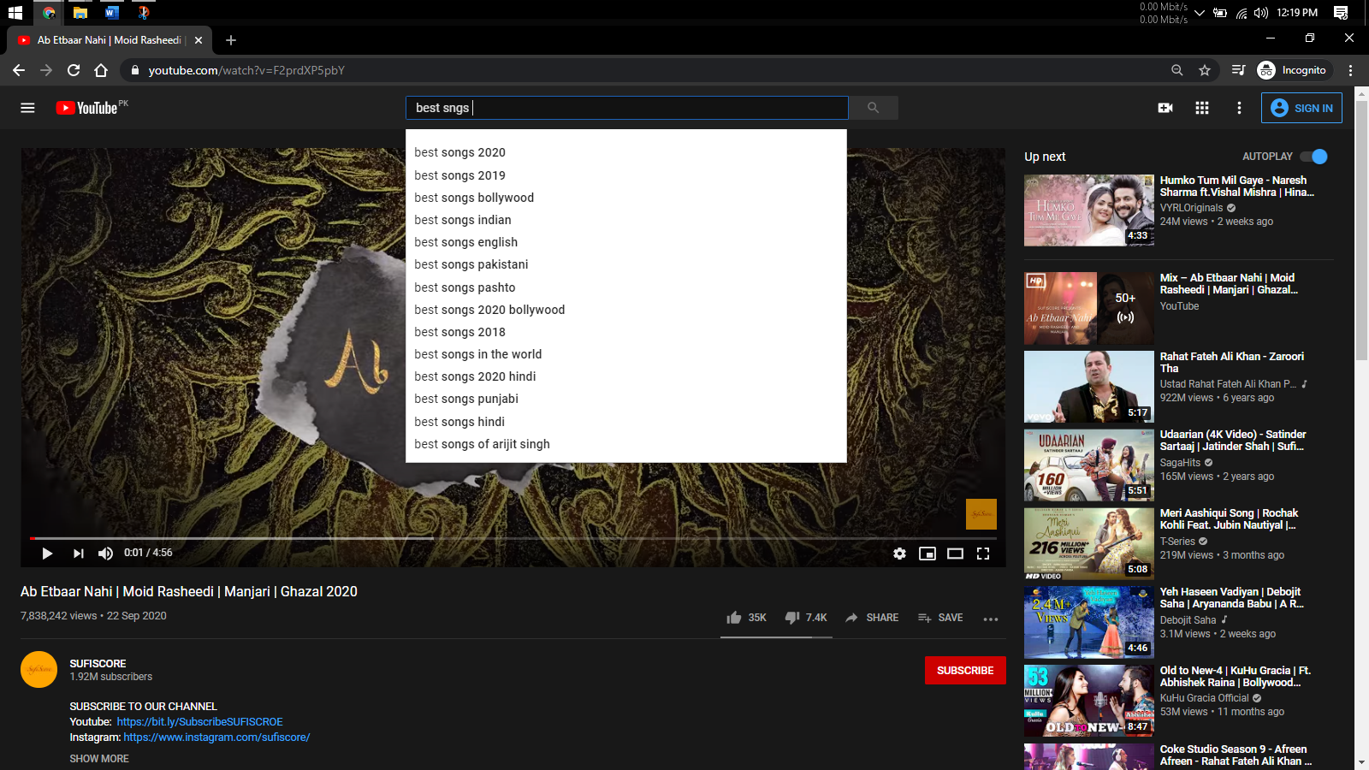

* Spelling Error Prevention

# Recognition rather than recall

* Use of Ions and Short key hints

# Flexibility and Efficiency of use

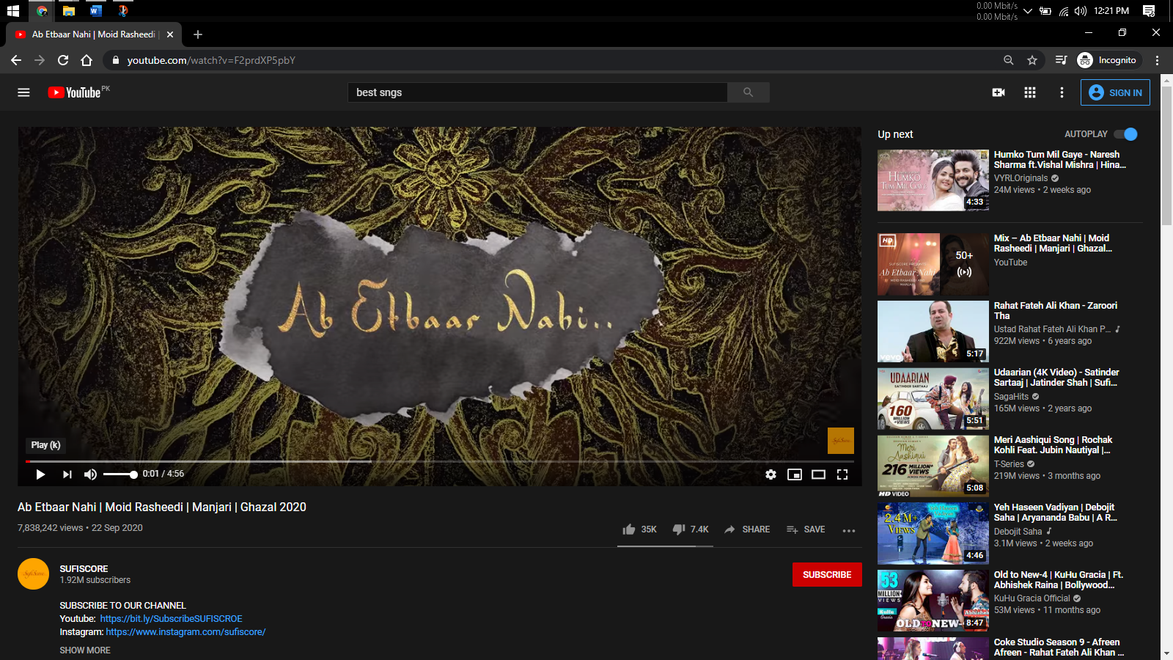

* Short Key Hints
* Remembers where you left
* Buffer data in advance

# Help and Documentation

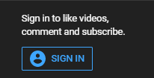

* Inline Documentation

# Aesthetic and Minimalist Design

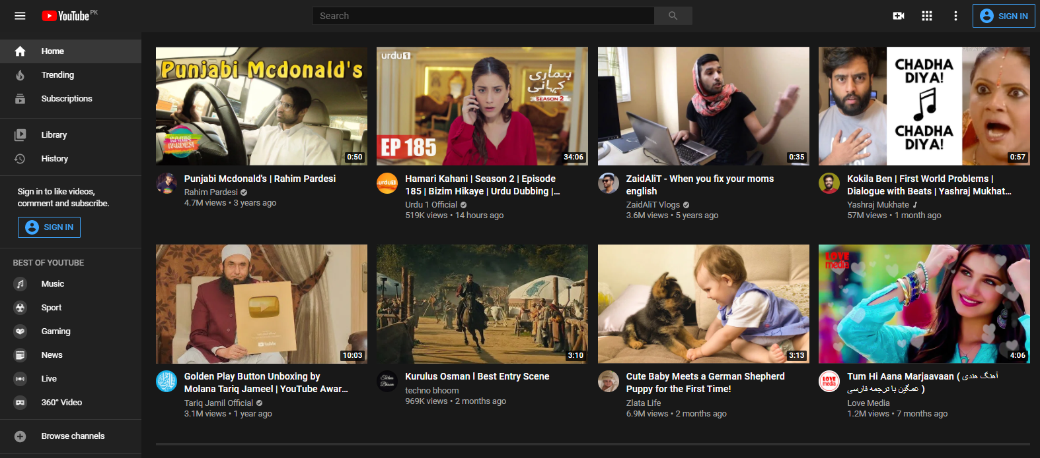

* Simple Menu Bar / Neat and clean design
* Click to play Videos / Even children use it without difficulty

# Help users Recognize, Diagnose and Recover from Errors

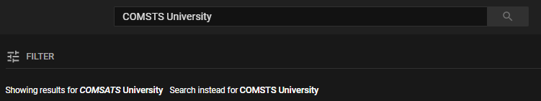

* Recovery from errors